Finney County COVID-19 Mass Vaccination Consent Form
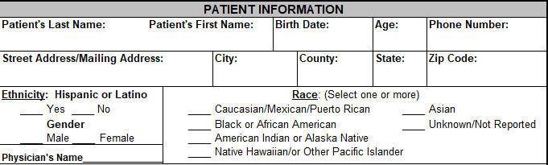
Occupation:_______________________________ Place of Employment: _____________________________________
I declare that I am 18 years of age or older. I further declare that I or my child:
- Have not experienced anaphylaxis (difficulty breathing) or severe allergic reactions from a previous vaccination or an injectable medication.
- Have not had any other vaccinations in the previous 14 days (e.g. MMR, Shingrix, Varicella, or a TB skin test).
- Is not currently sick with a fever, active respiratory infection or other moderate/severe illness.
- Have not received monoclonal antibodies or convalescent plasma for treatment of COVID-19 within the past ninety (90) days.
- Please refer to the Vaccine Fact Sheet to review the ingredients of the vaccine you are receiving.
- Have not had a positive COVID-19 result in the last 60 days.

I understand that if I have any of the above conditions, I could be at increased risk of having a negative reaction or problem from the vaccine.
I further declare that if I have any of the following conditions, I have had the opportunity to speak with my primary care provider and am making an informed decision to receive the vaccine:
- Pregnant, attempting to become pregnant or breastfeeding;
- Have a bleeding disorder or are on a blood thinner;
- Are immunocompromised or are taking a medication that affects the immune system (such as cortisone, prednisone, other steroids, or anticancer drugs; drugs for the treatment of rheumatoid arthritis, Crohn’s disease or psoriasis; HIV/AIDS, cancer, leukemia, ankylosing spondylitis or radiation treatments).

I agree to WAIT near the clinic location for 15 minutes after receiving the vaccine. If I have previously had a severe allergic reaction to a vaccine or injectable medication, I agree to WAIT near the clinic location for 30 minutes after receiving the vaccine.

I understand that the COVID-19 Moderna & Pfizer vaccine is a two-part vaccine series. By signing this consent, I am agreeing that I will receive the first and second part of the vaccine series. I understand that if I am receiving the Janssen vaccine it is a single dose vaccine.

- I understand that the common risks associated with the COVID-19 vaccine include but are not limited to pain, redness or swelling at the site of injection, tiredness, headache, muscle pain, chills, joint pain, fever, nausea, feeling unwell or swollen lymph nodes (lymphadenopathy).
- I understand that the vaccine may cause a severe allergic reaction which can include anaphylaxis (difficulty breathing, swelling of the face and throat, a fast heartbeat, a rash all over the body, dizziness and/or weakness).
- I understand that these may not be all the side effects of the COVID-19 vaccine as the vaccine is still being studied in clinical trials.
- I also understand that it is not possible to predict all possible side effects or complications which could be associated with the vaccine. I understand that the long-term side effects or complications of this vaccine are not known at this time.
I understand that the vaccination is being given by the Finney County COVID-19 Mass Vaccination Team. The owner and/or operator of this site, their affiliates, officers, directors, employees and agents expressly disclaim any responsibility for the vaccination.
My consent is given in light of this knowledge, and in consideration of the Finney County COVID-19 Mass Vaccination Team giving the COVID-19 vaccine. I, for myself and my heirs, administrators, trustees, executors, assigns and successors in interest do hereby agree to release and hold harmless the Finney County COVID-19 Mass Vaccination Team, its subsidiaries, divisions, affiliates, successors, assigns, officers, trustees, employees, volunteers and agents from and against any and all demands, damages, losses, costs, expenses, obligations, liabilities, claims, actions and cause of action (whether any of which is groundless or otherwise) of any nature whatsoever (including, without limitation, reasonable attorney’s fees and court costs) by reason of or resulting, in any way, from any and all acts, accidents, events, occurrences, omissions and the like related to, or arising out of, directly or indirectly, my receipt of this COVID-19 vaccine. The Finney County COVID-19 Mass Vaccination Team makes no warranties, express or implied, including but not limited to, implied warranties of merchantability or fitness for a particular purpose regarding the vaccine or its effectiveness. I acknowledge receipt of the Finney County COVID-19 Mass Vaccination Team’s Notice of Privacy Practices.

I have read and understood “What to Expect after Receiving a COVID-19 Vaccine” and the “Vaccine Fact Sheet” by the FDA regarding the COVID-19 Vaccination. I further understand and agree that the Finney County COVID-19 Mass Vaccination Team is required to submit COVID-19 vaccine administration data to the Kansas Immunization Information System (KSWebIZ), and report moderate and severe adverse events following vaccination to the Vaccine Adverse Event Reporting System (VAERS).

I understand and agree to all of the above and I hereby give my consent to the staff of the Finney County COVID-19 Mass Vaccination Team to give me a COVID-19 vaccine.

Signature: ______________________________________________________ Date: ________________________
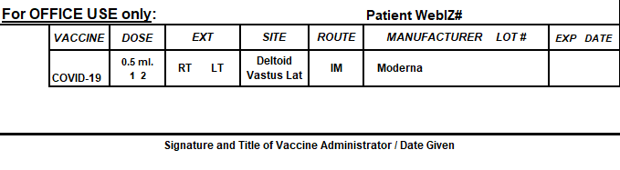

FINNEY COUNTY HEALTH DEPARTMENT
SUMMARY OF NOTICE OF PRIVACY PRACTICES
Date of Effectiveness: December 1, 2011
Dear Client,
This is a brief SUMMARY of our NOTICE OF PRIVACY PRACTICES. We are required by law to provide you with a copy of this notice for you or your child, and obtain your acknowledgment of its receipt prior to providing services to you or your child. If you would like a copy of the full version, please let us know and we will provide it to you. If you have questions concerning its content please let us know.
YOUR RIGHTS REGARDING YOUR PROTECTED HEALTH INFORMATION (PHI) This section describes the following rights you have with respect to your health information and tells you how you may exercise these rights.
- Right to inspect and copy your records
- Right to request amendment
- Right to an accounting of disclosures
- Right to request alternative means of communication
- Right to receive a paper copy of our NOTICE OR PRIVACY PRACTICES

HOW TO FILE COMPLAINTS CONCERNING OUR PRIVACY PRACTICES The section tells you what you can do if you believe any of your rights have been violated. You will not be penalized for filing any complaint.

HOW WE MAY USE AND DISCLOSE HEALTH INFORMATION ABOUT YOU WITHOUT YOUR AUTHORIZATION This section describes the different ways we may use or disclose your health information without first obtaining from you a specific authorization. Federal law specifically permits these types of uses and disclosures because it is assumed you would want us to use or disclose your information for these purposes or because such use or disclosure is recognized as critical to the proper function of our health care system.
You will be asked to acknowledge your receipt of this SUMMARY for yourself or your child. Your acknowledgment will be retained in your file. You should keep the original of this summary. Another copy of this summary will not be provided with subsequent visits, but you may request a copy of the summary at any time. If there is a material revision to this summary at some later date, you again will be provided with a copy of the summary and asked to sign an acknowledgment.
Maintaining the privacy of your health information is very important to us. Again, if you have any questions concerning the NOTICE OF PRIVACY PRACTICES or this summary, please do not hesitate to ask.
If you have questions, please contact:
Colleen Drees, Director
Finney County Health Department
919 Zerr Rd., Garden City, KS. 67846
(620) 272-3600 cdrees@finneycounty.org
I acknowledge that I have received a copy of this SUMMARY Of NOTICE OF PRIVACY PRACTICES, and that I have the right to receive a copy of the full NOTICE OF PRIVACY PRACTICES, with the effective date of 12/01/2011. Your receipt of care and treatment from Finney County Health Department is not conditioned upon your providing written acknowledgment.

______________________________________ ____________________________________________
Patient Date of Birth

_____________________________________ _____________________________________________
Signature of Patient/Patient Representative Relationship to patient

__________________________________
Date

